**High Concept Document**

**Intro**

This game is a top-down real time strategy game that pits 2 opposing teams against each other in a fight to the death. The team to have all of their troops and buildings destroyed first loses.

**Character Design**

The characters in this game are fairly simple in design but are unique to each other enough that they are easily distinguishable from one another.

Melee units look like a sword or weapon of sorts.

Ranged units look like a bow with an arrow.

Factory buildings are 2D representations of a hut.

Resource buildings look like a pickaxe.

The two teams are Red and Green and each unit or building is in the colour of their respective team.

**World Design**

The world is very simple and is just a grid of empty spaces that units or resources can occupy. There is an option to choose the size of the map when starting the game up, with a minimum and a maximum size set to avoid the game being broken.

**Flowboard**

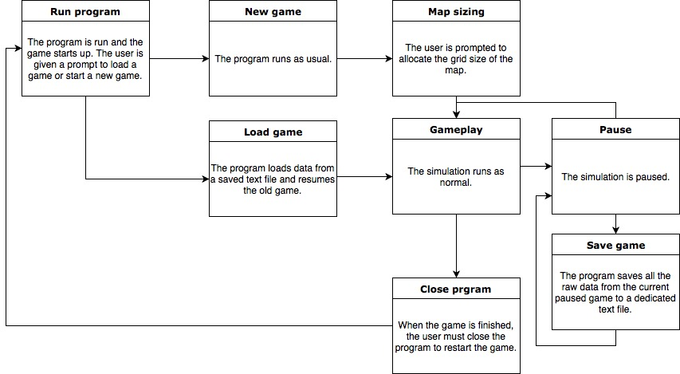

**Story and Level Progression**

As your troops and buildings fight and work respectively, they earn your team XP points, which slowly level up your team. If one of your troops kills an enemy troop, they get a certain amount of XP. The same happens if your troops destroy enemy buildings, but you gain much more XP from destroying an enemy building than from killing troops. As you gain XP points, your team will begin to level up. Levelling up grants spawned troops higher HP and attack damage, while also upgrading your buildings HP as well. As you level up, the amount of XP required to advance to the next level increases so as to avoid one team quickly getting ahead and demolishing the other team. The game is still a simulation, so the outcome of which team does better is purely random.

**GitHub Links:**

POE - <https://github.com/gilbarkai/My-RTS-Game>

Assignments - https://github.com/gilbarkai/Assignments-1-3

HCD - https://github.com/gilbarkai/High-Concept-Document